* **GTM (Google Tage Manager)**

GTM ( Google Tag Manager) they are small marketing tags we can keep on our website to track the user behaviors like button clicks, link clicks, page views cookie consent and track sessions.

1. **Tag = What do you want to do?**

Tags are **actions** that GTM performs — like sending data to Google Analytics, Facebook Pixel, or other tools.

1. **Trigger = When should it happen?**

Triggers **decide when a tag should fire**. They listen for things like clicks, page loads, scrolls, timers, or **custom events** you push into the Data Layer.

1. **Variable = What details do you want to include?**

Variables are **dynamic values** used by triggers and tags. They extract specific information — like the product name, category, URL, button text, etc.

* **GA4( Google Analytics 4)**

GA4 ( Google Analytics 4) is a tool which shows reports of our website about active users and event counts and all types of analytics.

**Step 1:** **Create a sample Webpage which includes some buttons, some links with the help pf HTML in VS Code.**

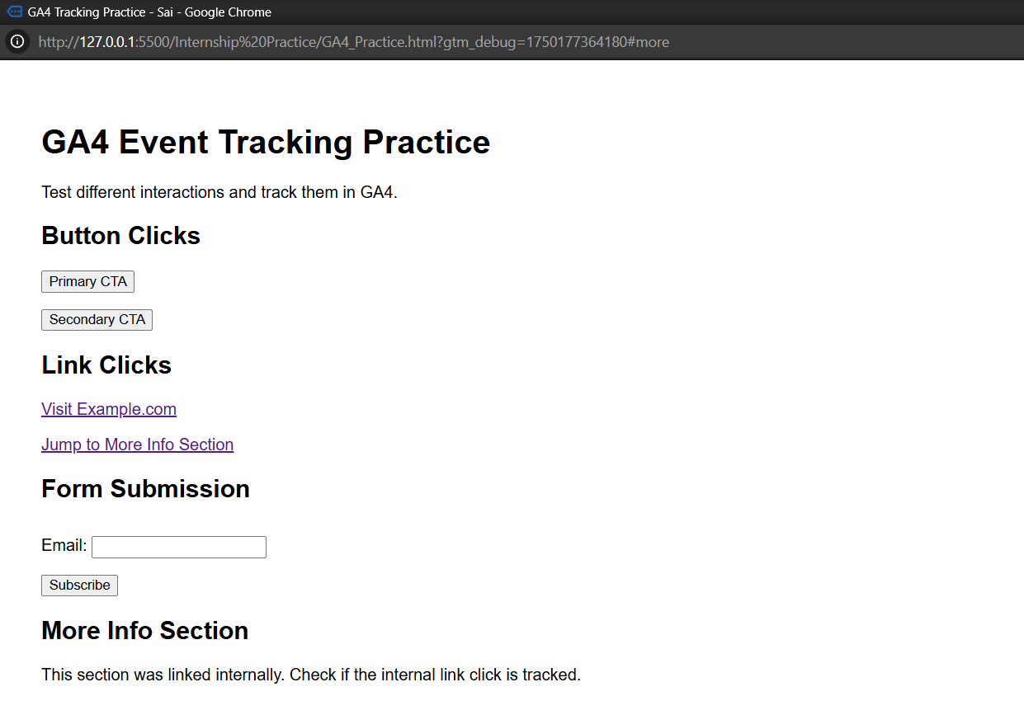

**Step 2: Add a Cookie Consent Banner**

* Visit [CookieScript](https://cookie-script.com/) website
* Create a **new project**
* Name the project
* Create a banner
* Style it according to your need
* Copy the script code and paste it into the **<head>** tag of your webpage code and open the webpage it would display the cookie consent banner.

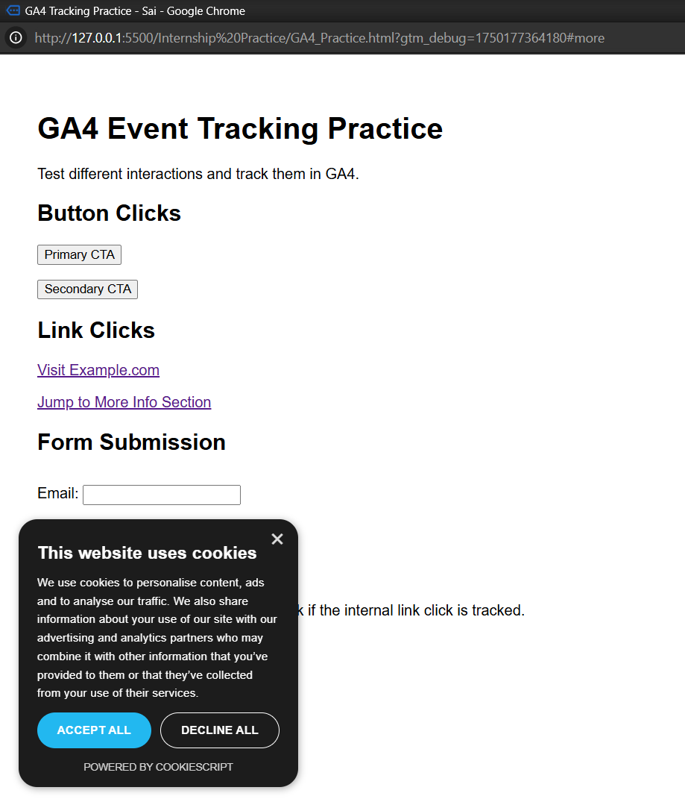

**Step 3**: **Create a Google Analytics Account**

* 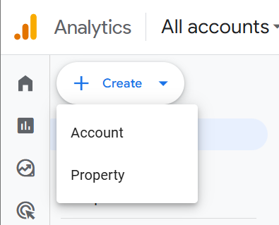Visit [Google Analytics 4](https://analytics.google.com/). Login using google account
* Click “Admin” (bottom-left gear icon). Click on **Create>Property**
* Fill Property details
  + - Property Name: Any name
    - Reporting time zone: India IST
    - Currency: INR
    - Click **Next**
* Choose Business Info. Click **Create.**
* Set up a Data Stream
  + Choose Platform (Web, IOS, Android)
  + Since we’ll use a sample website use **Web**
  + Enter website URL
  + Enter stream name.
  + Click **Create Stream**
* It provides you with a Measurement ID, Copy it and paste it under the <head> tag of your website code

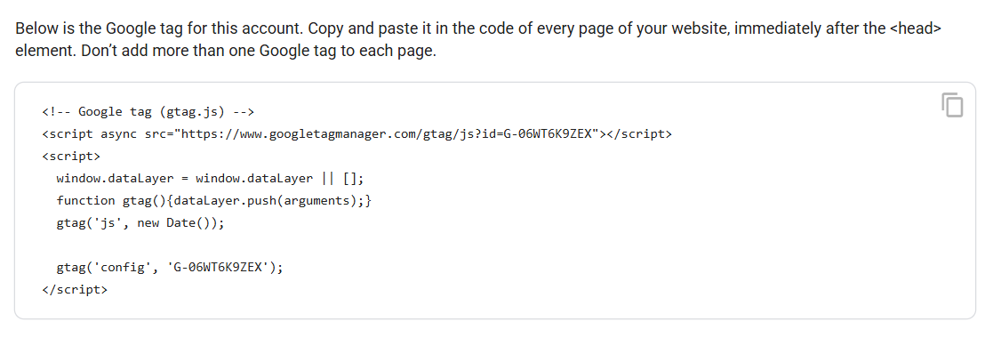

* When open and click the button on the sample web page it gets updated on the GA4 dashboard

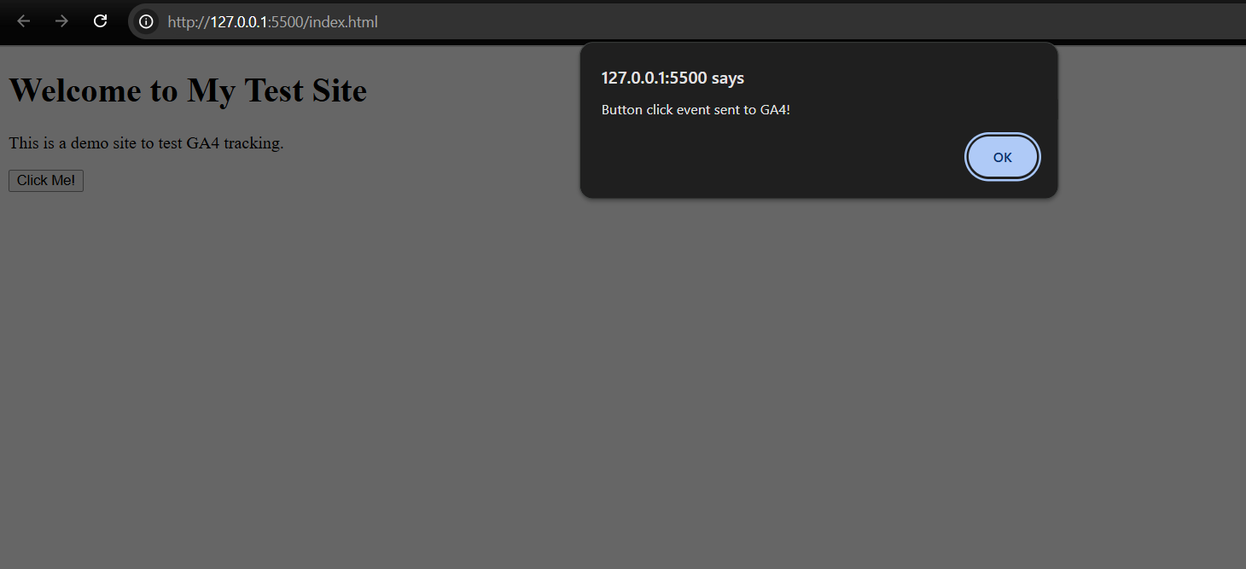

* Click on real-time in GA4 and view your GA4 dashboard

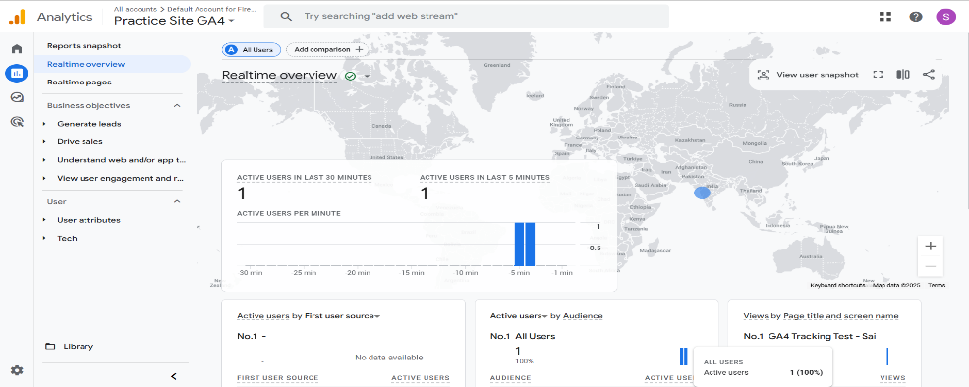

**Step 4: Create GTM Container**

* Visit [GTM](https://tagmanager.google.com/#/home)
* Create Account
* Name your account
* Select Country India
* Name your container
* Select Target Platform Web

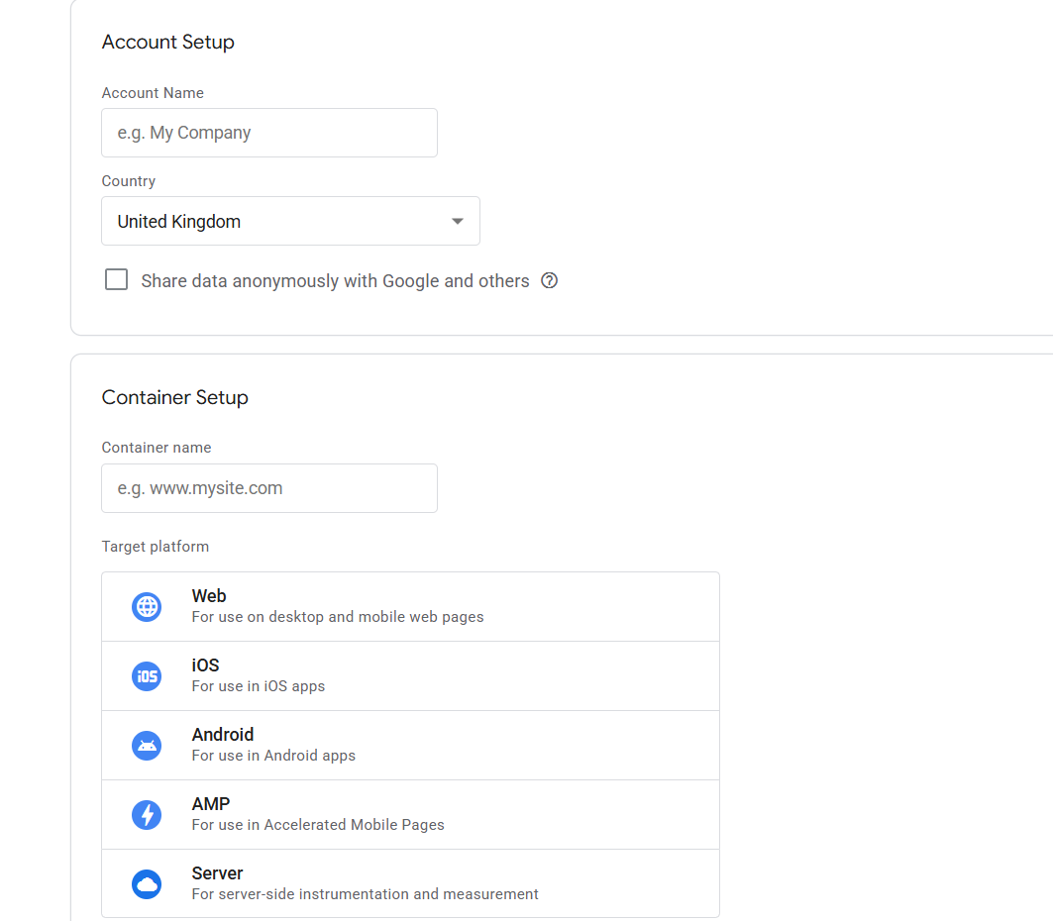

* Click **Create** and we will get **GTM Container code**
* One code to insert in **<head>** tag and on in the **<body tag>**
* Once GTM code is added to your site, go back to **tagmanager.google.com**
* Click **“Submit”** at the top right.
* Name the version (e.g., “Initial setup”) and click **“Publish”**
* Go to the **“Tags”** section → click **“New”** → name it: **GA4 – Config**
* Click on “**Tag Configuration” → choose “Google Analytics: GA4 Configuration”**
* Enter your Measurement ID (starts with G-, like **G-06WT6K9ZEX**)

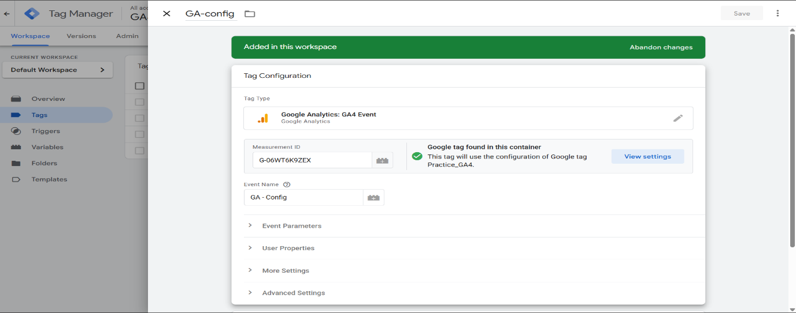

* 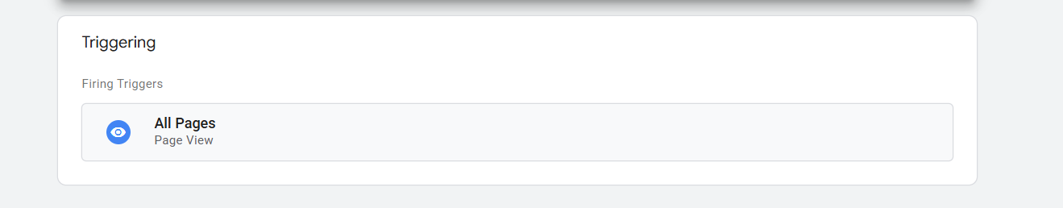Click “**Triggering”** → select **“All Pages”**
* Click Save
* Click **Tags → New → name it: GA4 – Button Click**
* Choose Tag Type: **Google Analytics: GA4 Event**
* In Configuration Tag, select the GA4 Config tag you created earlier

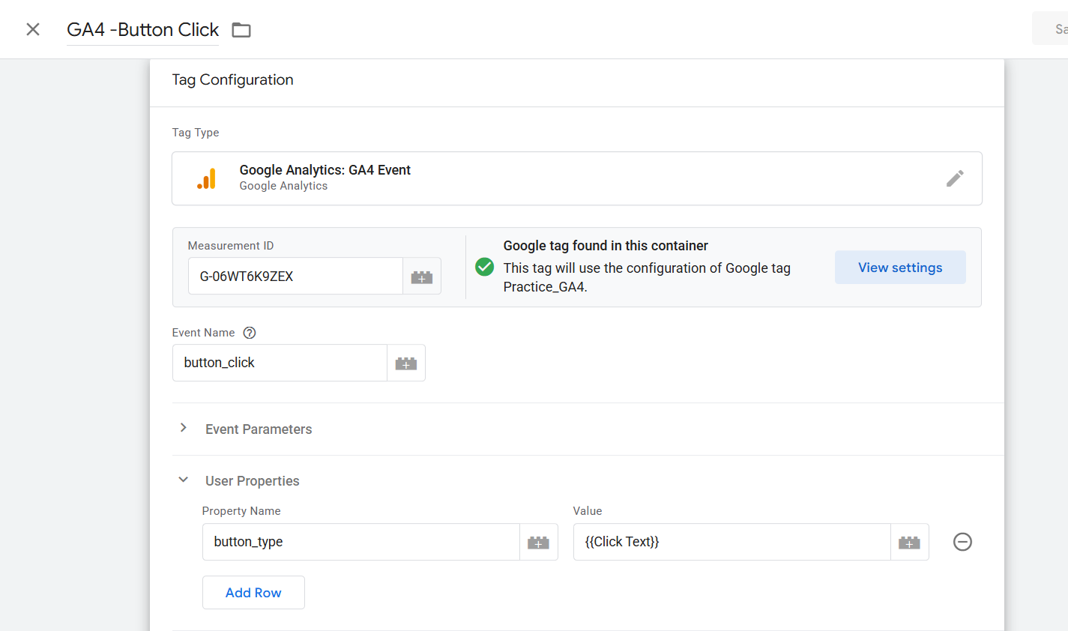

* Event Name: **button_click**
* For Triggering:
* Click **Triggering → New Trigger → name it: Button Click Trigger**
* Type: Click – All Elements
* Configure it to fire on: Some Clicks
* Choose: **Click Text → contains → (you can enter "Primary" or leave broad for now)**

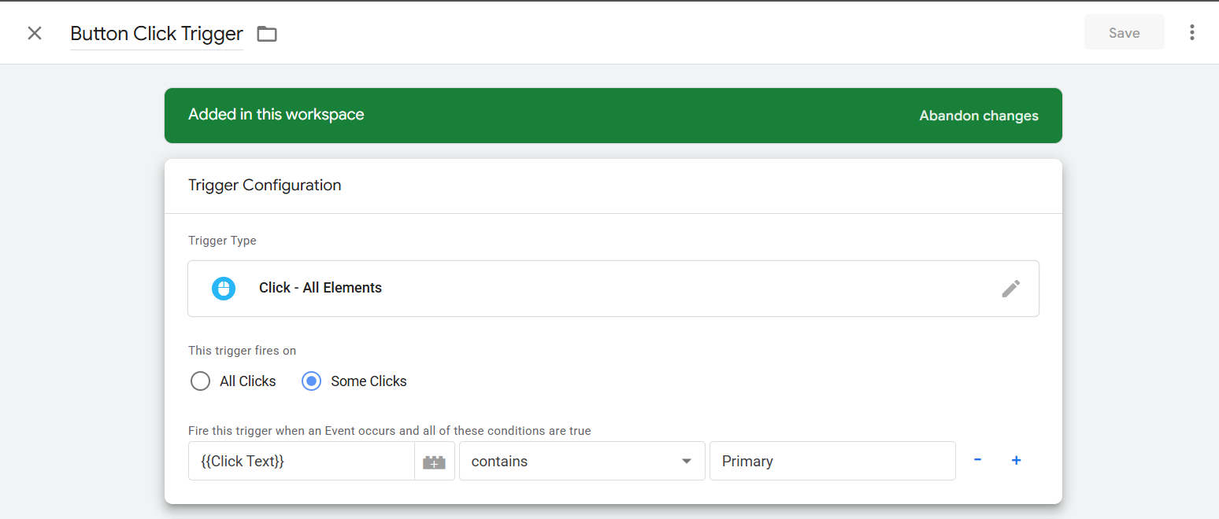

**Step 5: Click Preview**

* Enter website domain or URL
* Click Connect
* Perform some activity on the webpage the events will be displayed in the GTM Tag assistant summary